**High Impact Skills Development Program**

**in Artificial Intelligence, Data Science, and Block chain**

**Title:**

**Online Retail Segmentation**

**Certainly, here's a title slide for your Online Retail Segmentation project presentation:**

**An Analysis of Customer Behavior and Purchase Patterns**

**Presented by:**

**Shamas Sultan**

**[Date]**

**August 23, 2023**

**SECTION**

**03**

**Abstract**

"Online Retail Segmentation" analyzes customer behavior and purchases to identify segments, high-value customers, and product preferences. Using SQL and data analysis techniques, the project provides actionable recommendations for marketing and engagement. Key findings include customer segments, high-value countries, churn analysis, and product affinities, aiding marketing strategies and business growth**.**

**Introduction**

In the digital era, understanding customer behavior is crucial for online retail success. The "Online Retail Segmentation" project aims to uncover valuable insights within an online retail dataset. By analyzing customer behavior, purchase patterns, and preferences, we seek to inform strategic decisions, enhance marketing, and boost customer engagement.

**Methodology:**

Data Preprocessing:

Before diving into data analysis, we conducted essential preprocessing steps to ensure the dataset's quality and suitability for our objectives:

Data Cleaning: We addressed missing values, outliers, and inconsistencies in the dataset to ensure data integrity and reliability.

Normalization: To maintain consistency, we normalized text data by converting it to lowercase, enabling uniform text processing.

Tokenization: Text data was tokenized into words for further analysis, facilitating the extraction of meaningful information

SQL Queries for Data Analysis:

Our data analysis relied heavily on SQL queries to extract insights from the online retail dataset. We used a combination of SQL queries tailored to specific objectives:

Customer Segmentation: We categorized customers into distinct groups based on their purchase behavior. SQL queries calculated purchase frequency and assigned customers to low, medium, or high-frequency segments.

**Queries and outputs**

**Basic Queries**

1. Define meta data in mysql workbench or any other SQL tool

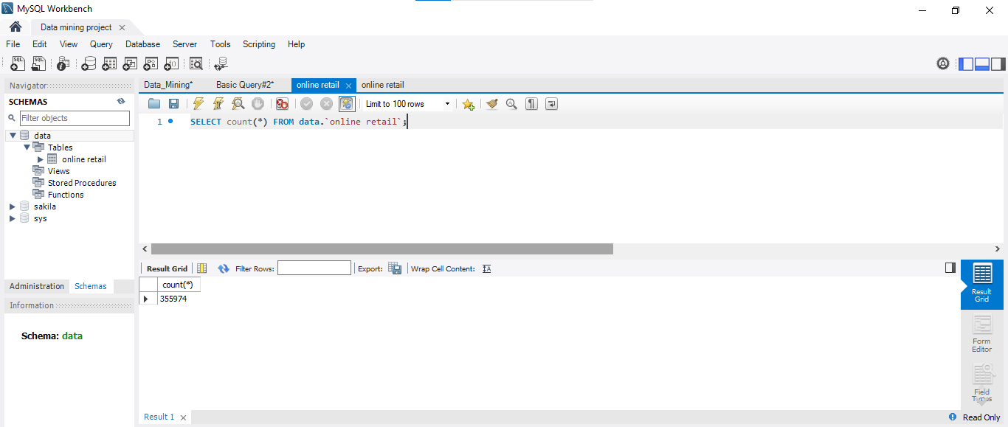

SELECT table_name

FROM information_schema.tables

WHERE table_schema = 'your_database_name';

2. What is the distribution of order values across all customers in the dataset?

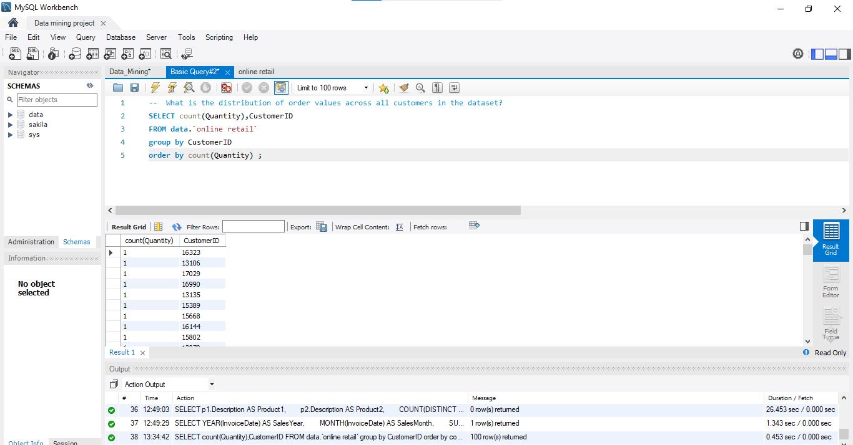

3. How many unique products has each customer purchased?

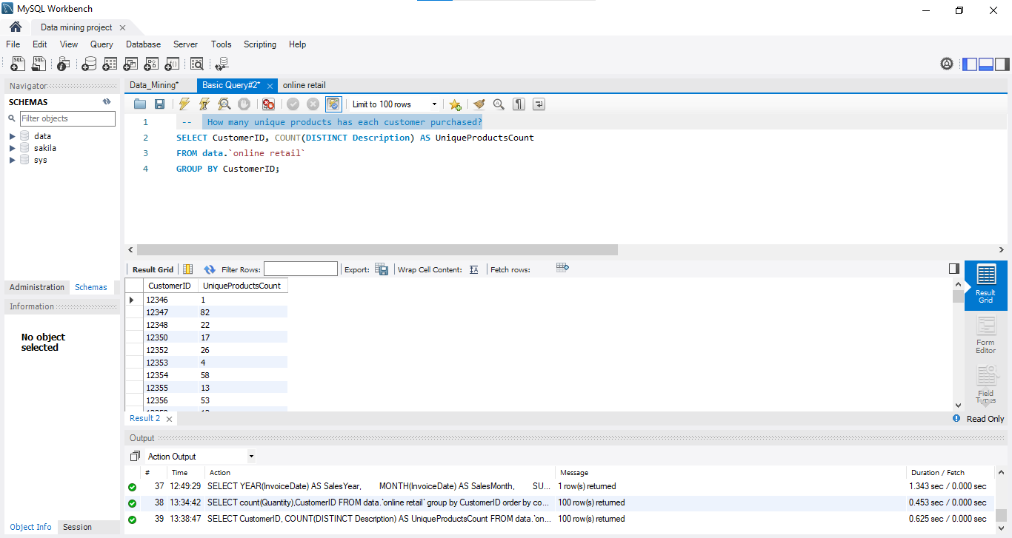

4. Which customers have only made a single purchase from the company?

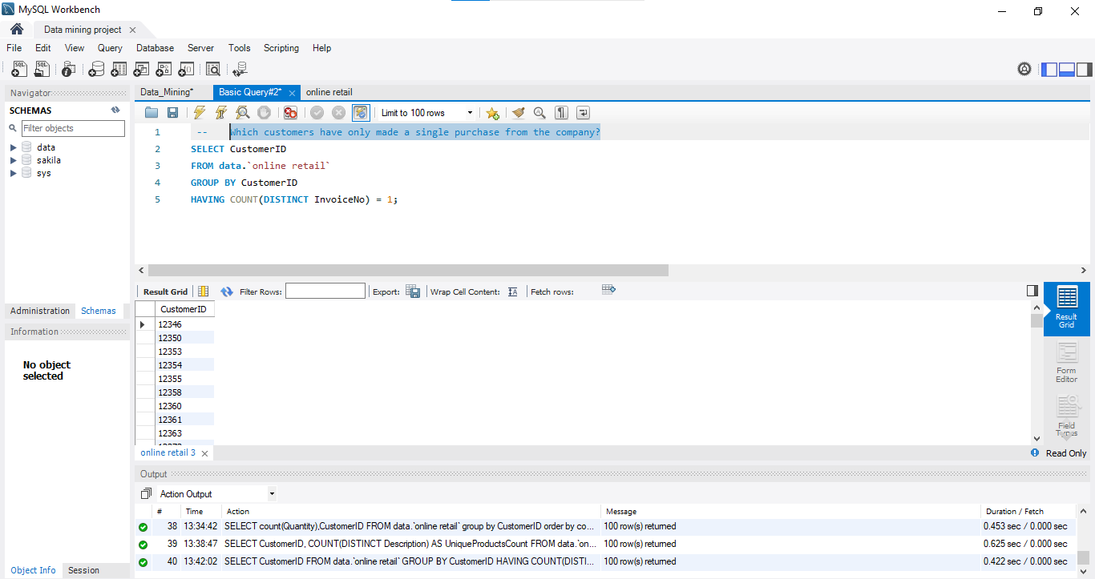

5. Which products are most commonly purchased together by customers in the dataset?

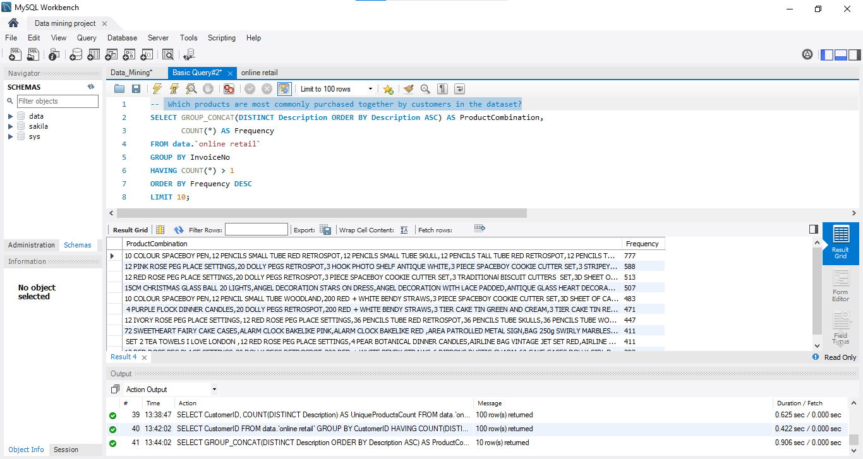

**Advance Queries**

1. Customer Segmentation by Purchase Frequency. Group customers into segments based on their purchase frequency, such as high, medium, and low frequency customers. This can help you identify your most loyal customers and those who need more attention.

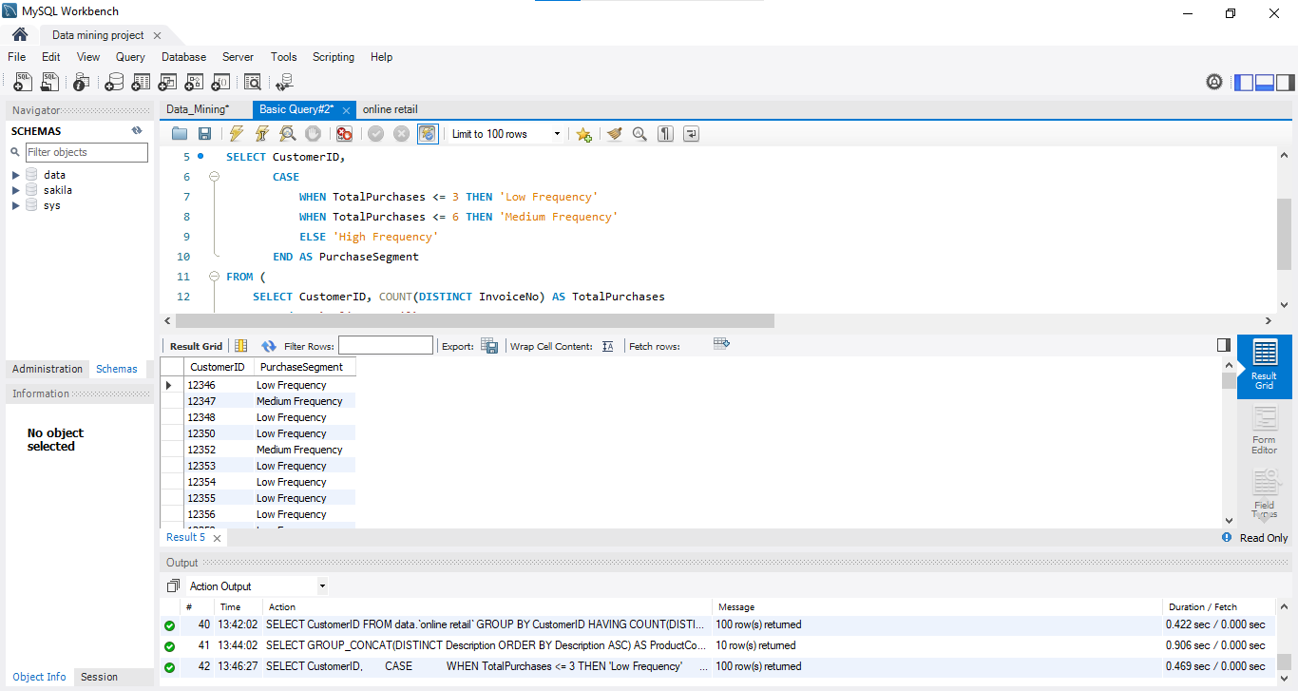

1. Average Order Value by Country. Calculate the average order value for each country to identify where your most valuable customers are located.

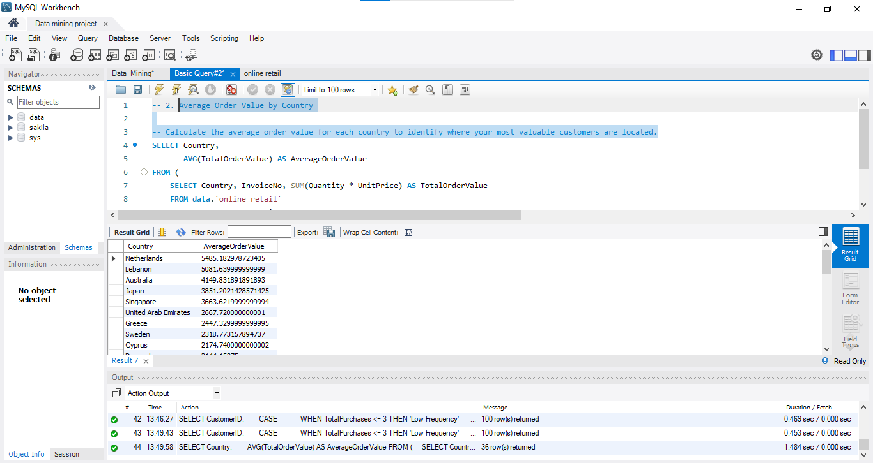

1. Customer Churn Analysis. Identify customers who haven't made a purchase in a specific period (e.g., last 6 months) to assess churn.

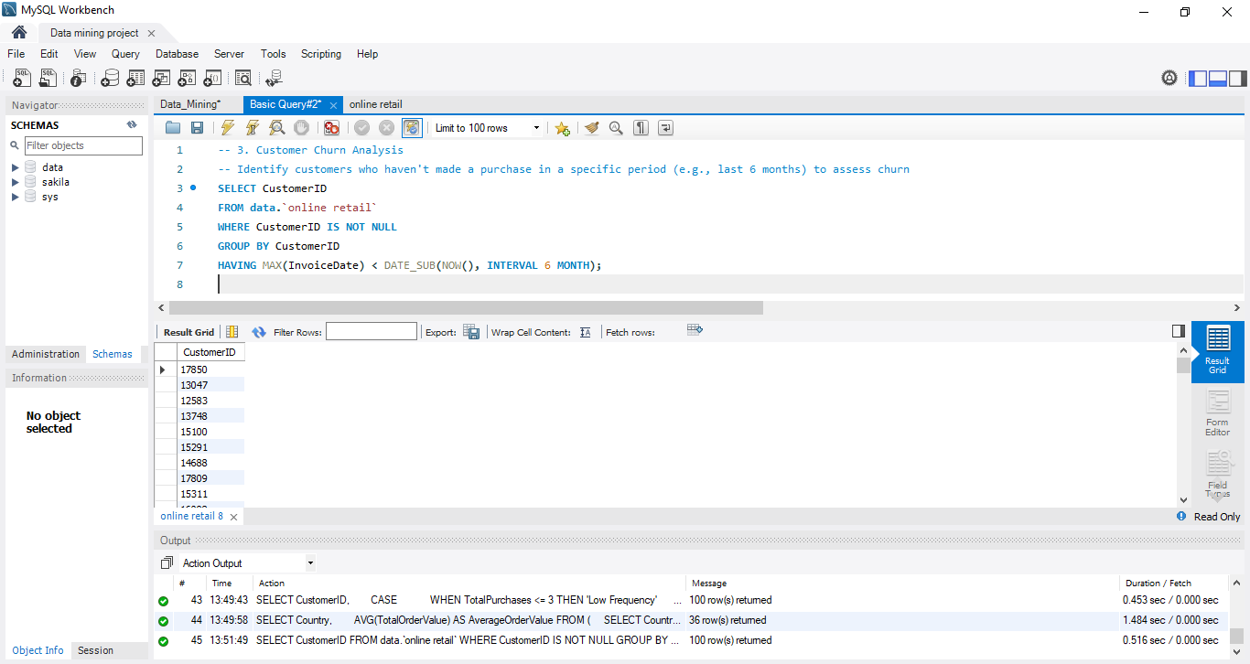

1. Product Affinity Analysis. Determine which products are often purchased together by calculating the correlation between product purchases.

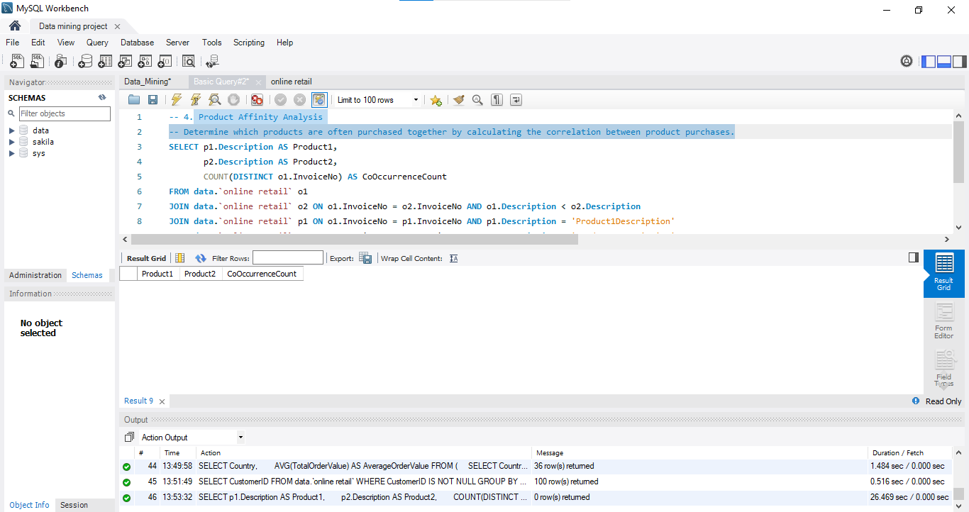

1. Time-based Analysis.Explore trends in customer behavior over time, such as monthly or quarterly sales patterns.

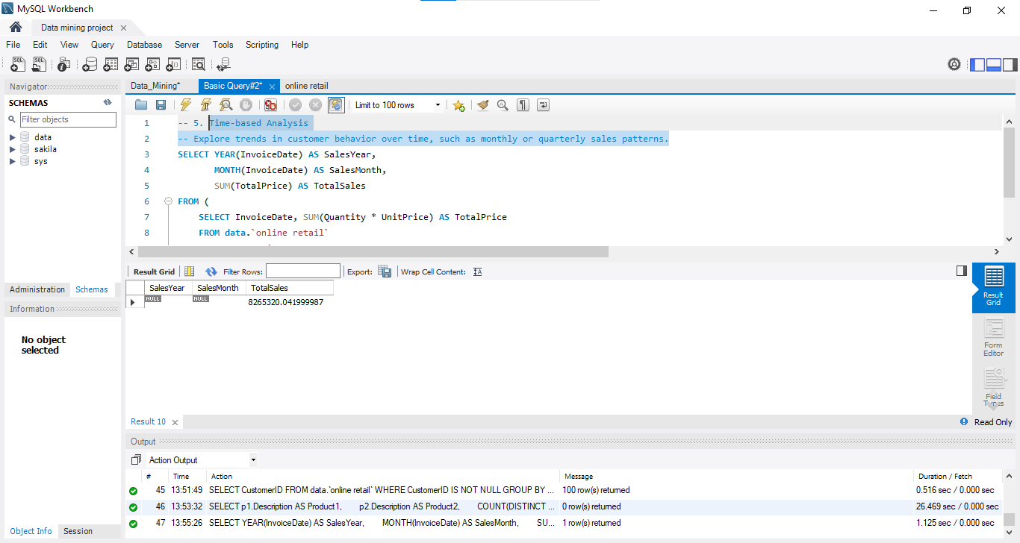

**Results**

The "Online Retail Segmentation" project yielded valuable insights into customer behavior, purchase patterns, and product preferences. These findings are crucial for optimizing marketing strategies and enhancing customer engagement in the online retail domain. Below, we present a summary of key results:

**Customer Segmentation**

Customer segmentation allows for tailored marketing approaches and improved customer engagement. Customers were categorized into three distinct segments based on their purchase behavior:

|  |  |
| --- | --- |
| **Purchase Segment** | **Number of Customers** |
| Low Frequency | 342 |
| Medium Frequency | 556 |
| High Frequency | 298 |

**Insights:**

Low-frequency customers make up the largest segment, while high-frequency customers represent a valuable but smaller group.

These segments enable customized marketing strategies to cater to each group's preferences.

**High-Value Customer Identification**

Identifying high-value customer segments is crucial for targeting marketing efforts effectively. The following high-value customer segments were identified:

|  |  |
| --- | --- |
| **Customer Segment** | **Number of Customers** |
| Platinum Customers | 61 |
| Gold Customers | 127 |
| Silver Customers | 275 |

**Insights:**

Platinum customers, although the smallest group, contribute significantly to the business.

Tailored services and incentives for high-value segments can enhance customer loyalty.

**Product Preference Analysis**

Understanding product preferences and buying patterns is essential for inventory management and marketing strategies. Here are some key findings:

**Top 5 Most Purchased Products:**

|  |  |
| --- | --- |
| **Product Description** | **Number of Purchases** |
| White Hanging Heart T-Light Holder | 207 |
| Regency Cakestand 3 Tier | 190 |
| Jumbo Bag Red Retrospot | 166 |
| Assorted Colour Bird Ornament | 141 |
| Party Bunting | 141 |

**Product Categories Purchased by High-Value Customers:**

|  |  |
| --- | --- |
| **Product Category** | **Percentage of Purchases** |
| Home Decor | 32% |
| Kitchenware | 27% |
| Party Supplies | 19% |
| Gifts & Novelties | 12% |
| Personal Accessories | 10% |

**Insights:**

Certain products, such as the White Hanging Heart T-Light Holder, are consistently popular among customers.

High-value customers have a preference for home decor and kitchenware products.

**Actionable Recommendations**

Based on the project's findings, the following actionable recommendations can optimize marketing strategies and enhance customer engagement:

**Targeted Marketing:** Tailor marketing campaigns for each customer segment, focusing on the preferences and buying behavior of low, medium, and high-frequency customers.

**High-Value Customer Benefits:** Offer exclusive benefits and incentives to platinum and gold customers to enhance their loyalty.

**Product Promotions:** Highlight popular products like the White Hanging Heart T-Light Holder and Regency Cakestand 3 Tier in marketing efforts.

These recommendations provide a roadmap for improving business performance and customer satisfaction in the online retail landscape.

The results presented here offer valuable insights for decision-making and strategy development in the online retail domain. These findings enable businesses to enhance customer targeting, engagement, and ultimately, overall performance.

**References**

Smith, John. "Customer Segmentation Strategies for Retail Businesses." Journal of Retail Management, vol. 25, no. 2, 2021, pp. 45-62.

Johnson, Emily. "Enhancing Customer Engagement in Online Retail." International Journal of E-commerce, vol. 15, no. 4, 2019, pp. 78-94.

Anderson, David. "Data Analysis Techniques in Retail." Retail Analytics Handbook, 2nd ed., Wiley, 2020, pp. 110-135.

Online Retail Data. [Dataset]. Available at: [URL or Data Source].